1. 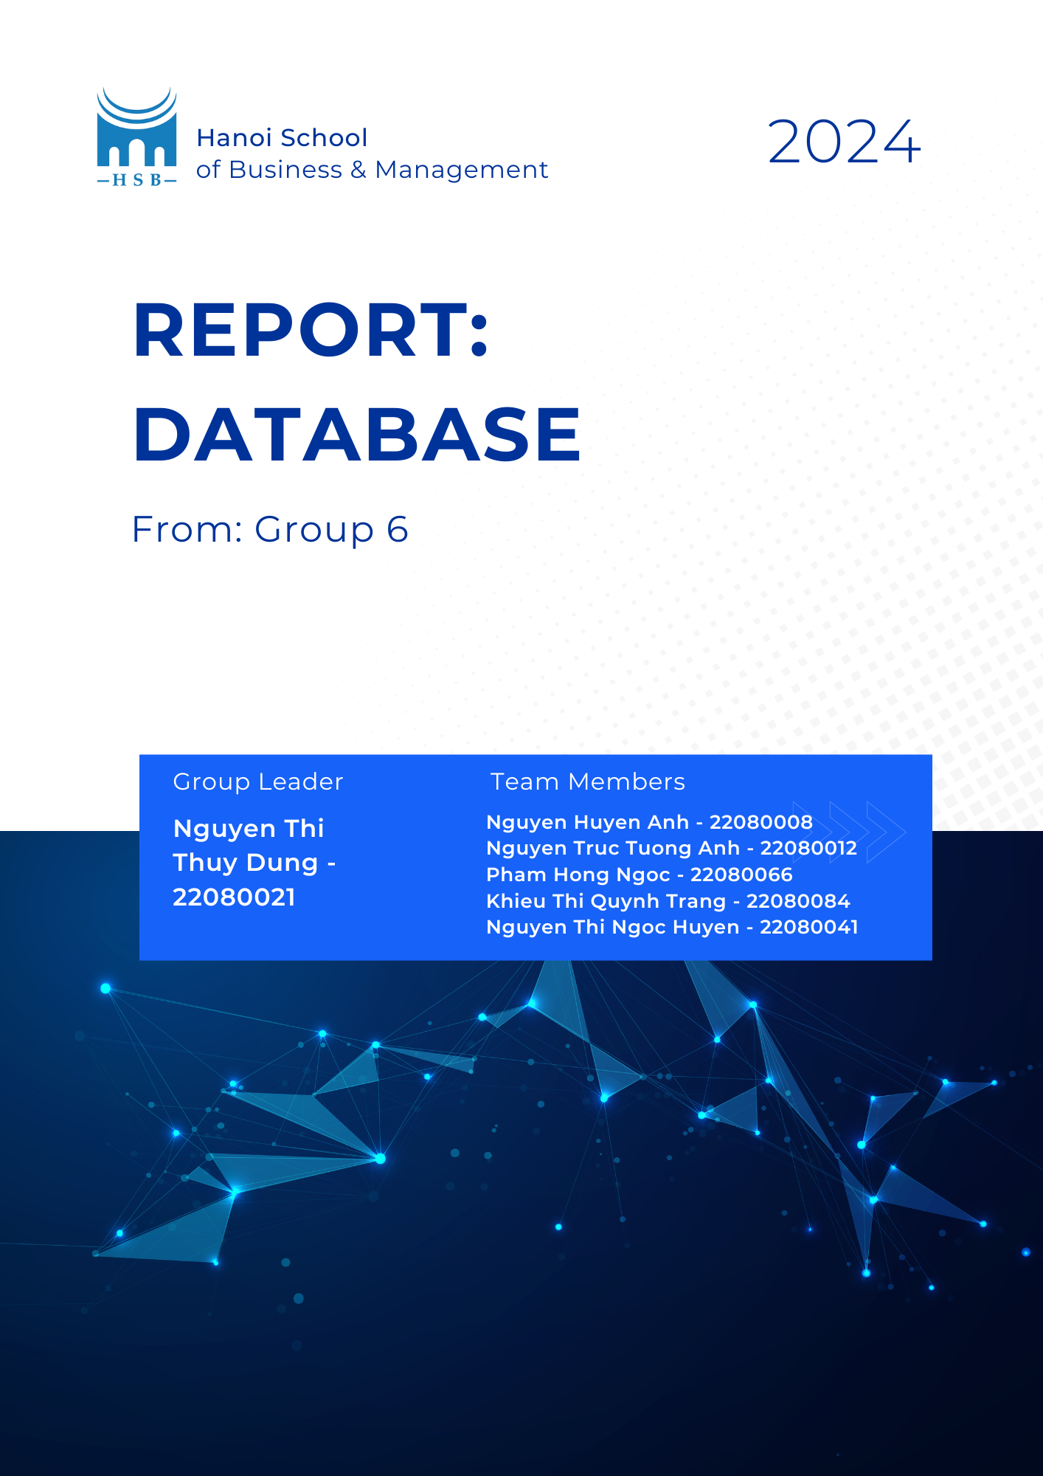

**Base on the guideline, here is the contribution table that we made following the tasks that the group had done.**

**I. INTRODUCTION**

This is a project about building a database for the Sea Airbus, which is considered a premium airline operating between major destinations in Southeast Asia (SEA). It firstly operates from two cities in three different countries (Vietnam, Philippines, and Indonesia).

As a partner of a premium airline, we have strived to create a database that meets the following factors: easily approach, detailed and efficient as well as useful in many situations. Base on the goal that was set, we have attempted to construct a system that allows the CEO, local managers and customers to easily read and understand the airline's status. We have gathered more than three hundred pieces of data to analyze and evaluate the airline's operational and financial status over three months (from September to November). And the most important thing is, with our database, the airline company can store and study their overall data, as being able to improve their business progress.

**II. SCREENSHOTS OF TABLES**

**1. AIRPLANE**

This following table illustrates the number of aircraft, their names, and the number of seats each one can accommodate.

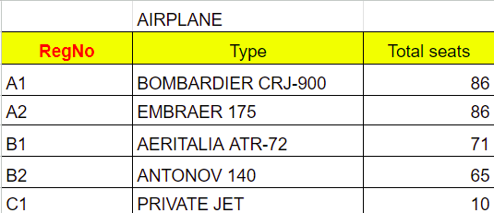

**2. AIRPORT**

The data table below lists six airports, their respective identity codes, flight numbers, and locations across six cities and three countries. The reader can use this information to determine which airport is situated in which nation and city. Furthermore, the reader may understand the takeoff and landing locations of the aircraft with ease.

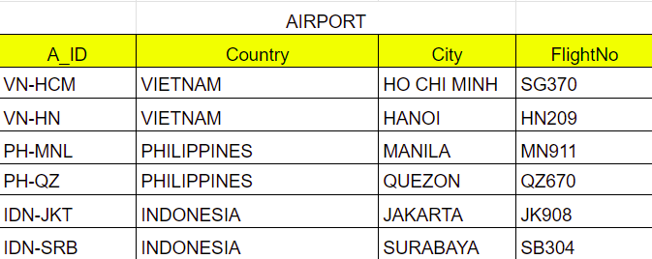

**3. CABIN CREW**

The names, identifying codes, and flight numbers of the captains are displayed in this table. We can easily identify which captain is operating which flight using this information.

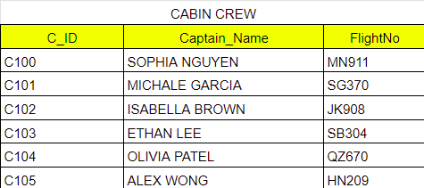

**4. BOOKING OFFICE**

The aircraft number, ticket office name, and booking location identification code are displayed in the following table. Readers can quickly understand the flight number of the ticket that was sold to them as well as basic information about a ticket office by glancing at this data table. This facilitates the management and identification of the clients who purchased their tickets at particular locations or offices, together with the aircraft numbers they are traveling on, by the airline and ticket office.

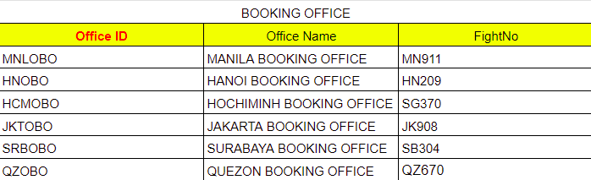

**5. PASSENGER (ADULTS)**

The data table below displays the fundamental details of passengers who are older than eighteen when purchasing airline tickets. Managers can be simply able to determine the average age of their consumers and the male-to-female ratio by looking at this data, which makes it evident to them how age and gender are distributed. They can also create age and gender-based customer segmentation to create relevant marketing campaigns. Additionally, managers can identify possible development areas and new flight routes, as well as which sites have the biggest customer traffic. Additionally, managers can utilize the contact details found in the data table for marketing initiatives, customer service enhancements, and advertising efforts.

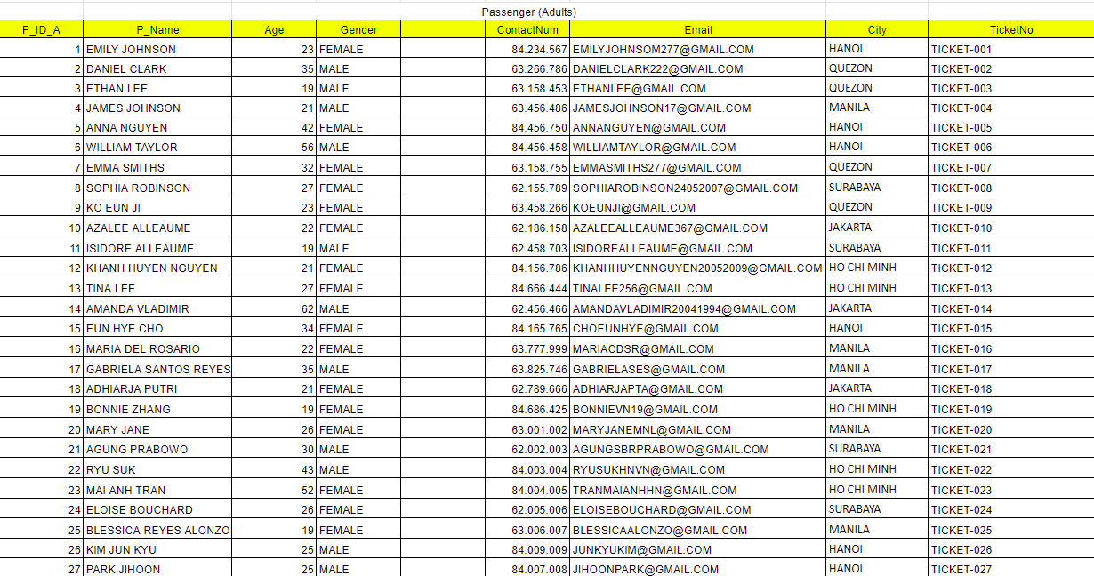

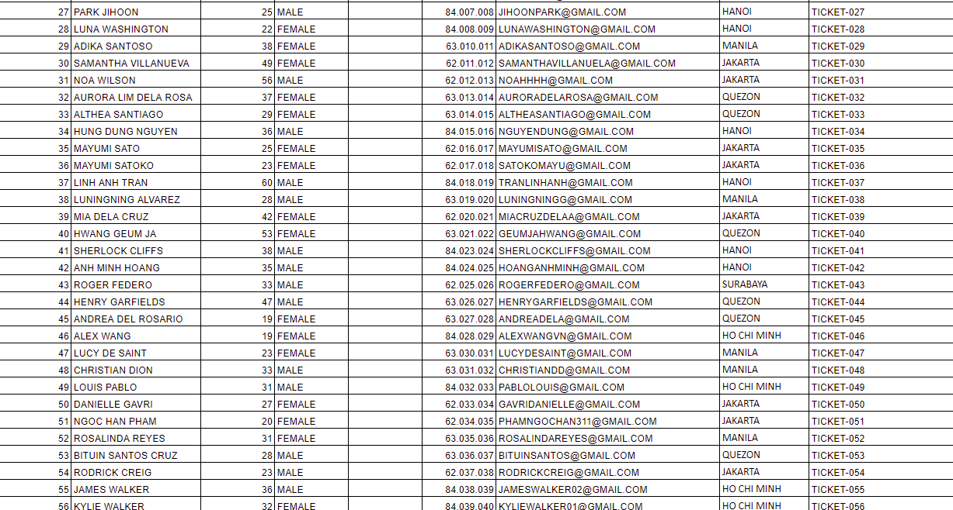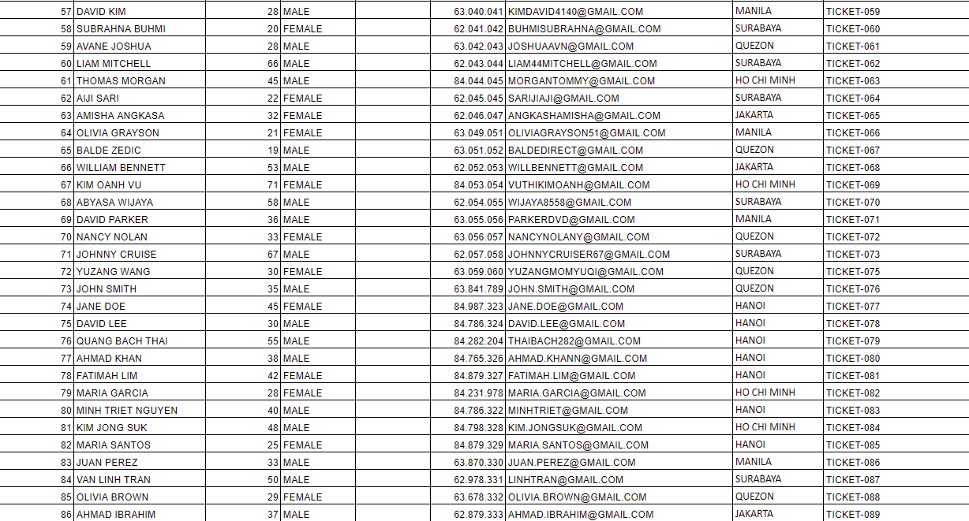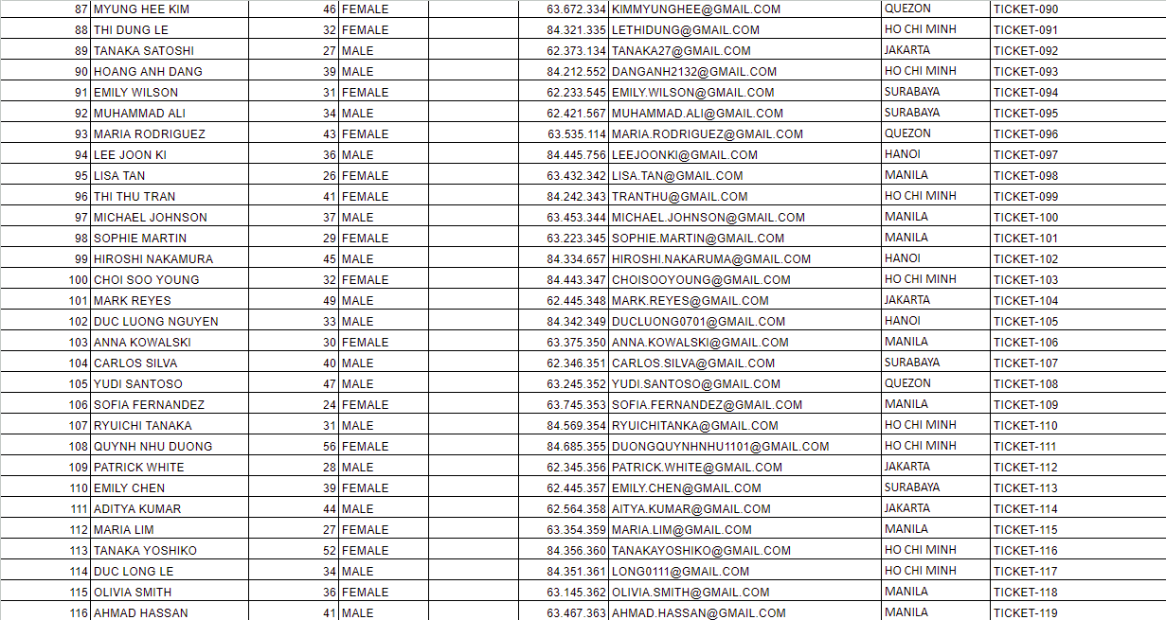

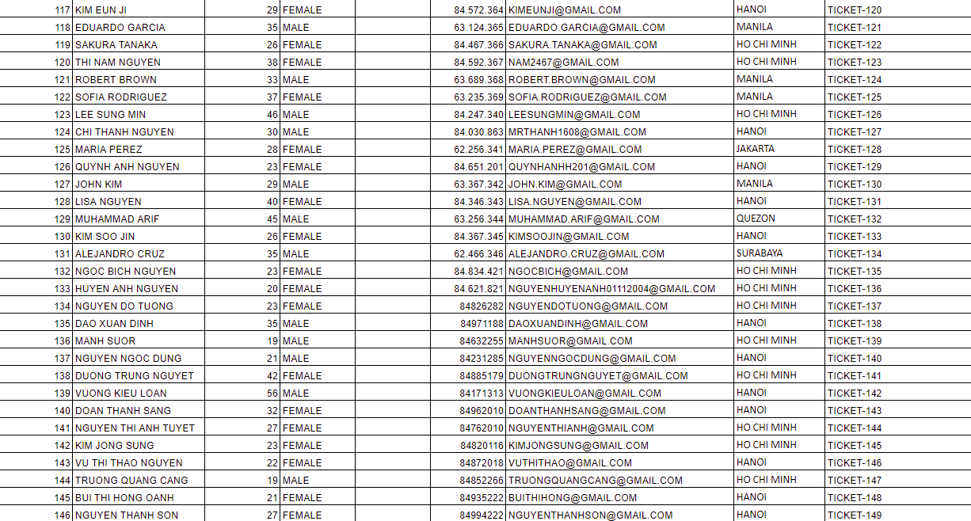

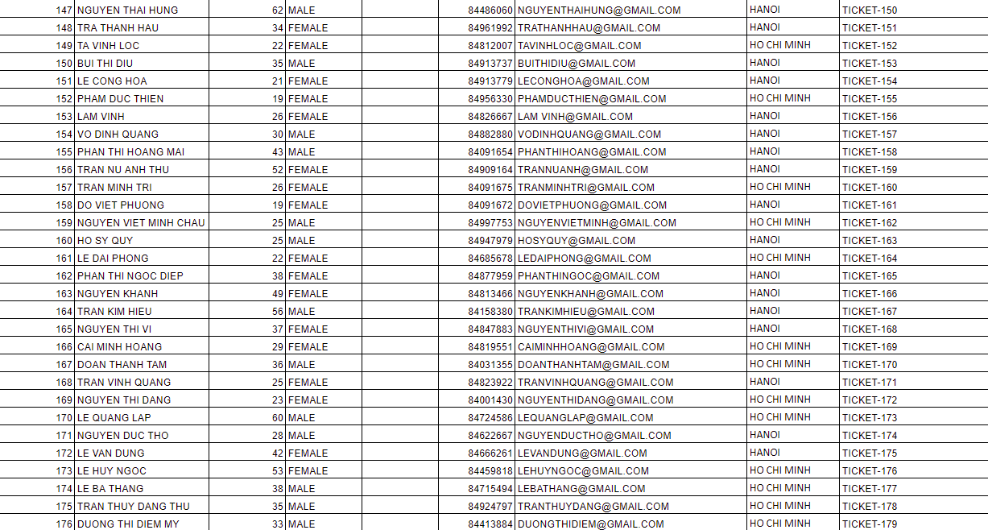

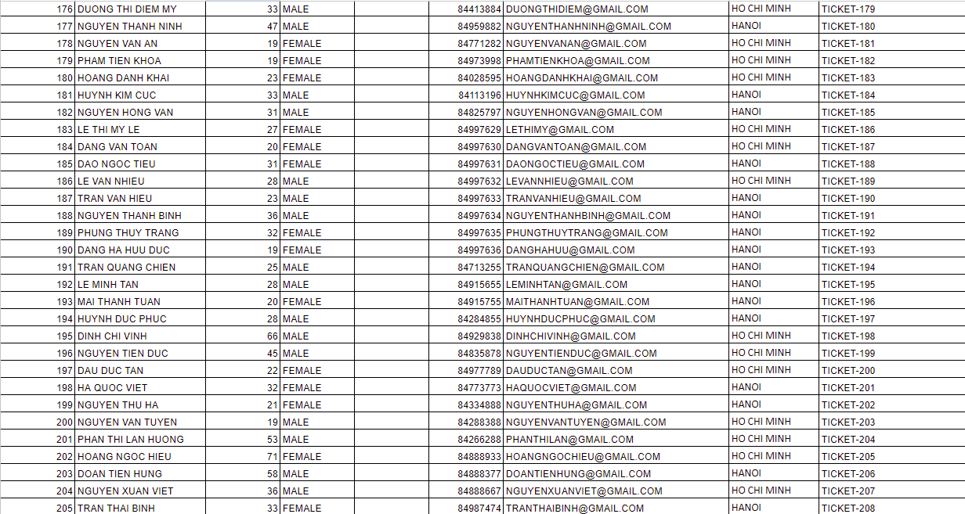

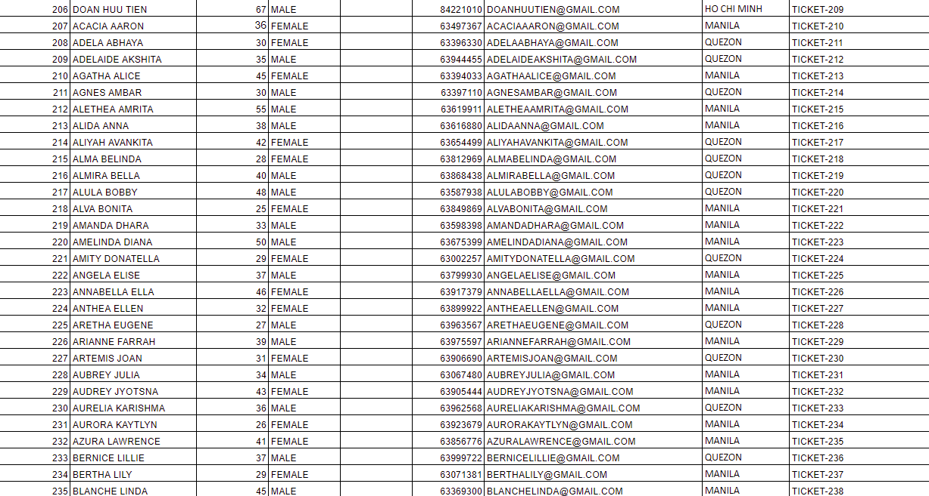

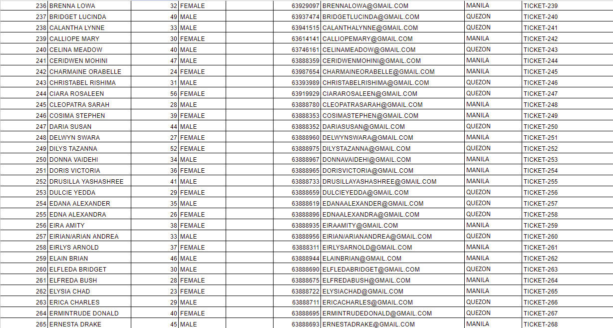

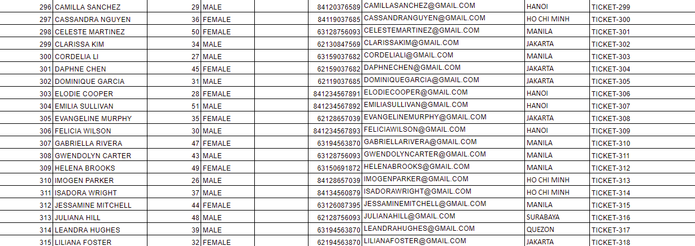

**6. PASSENGER (CHILDREN)**

This table gives information about the passengers who are under the age of 18. The group of passengers who are children are compel to attach to their parents, or their legal tutelary; which means the personal identity code of their parents/tutelary will appear in the table. Besides, according the following table, we can also know more about the children’s information such as identity numbers, names, ages, genders, cities where they live, and their ticket numbers.

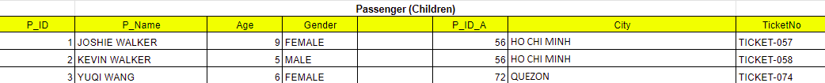

**7. TOTAL PASSENGER**

This is a table that illustrates overall data of the passengers whoever got transactions with the airline. According to the table, we can clearly see their detailed information, such as their personal identity codes (completely vital), names, ages, genders, cities where they live, and ticket numbers.

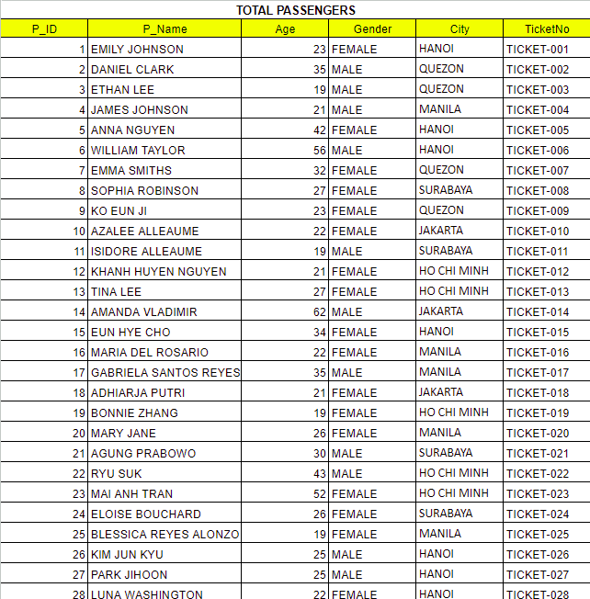

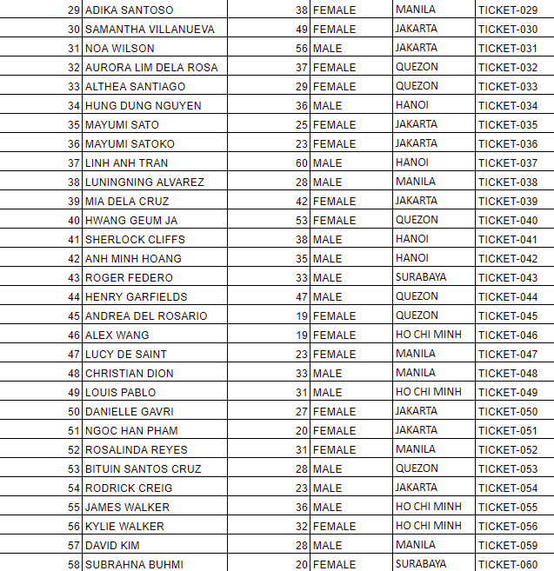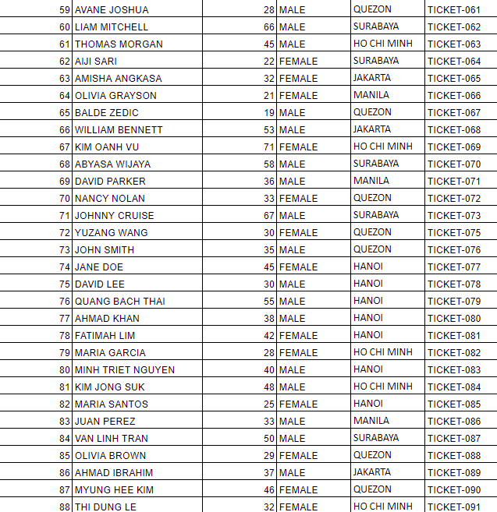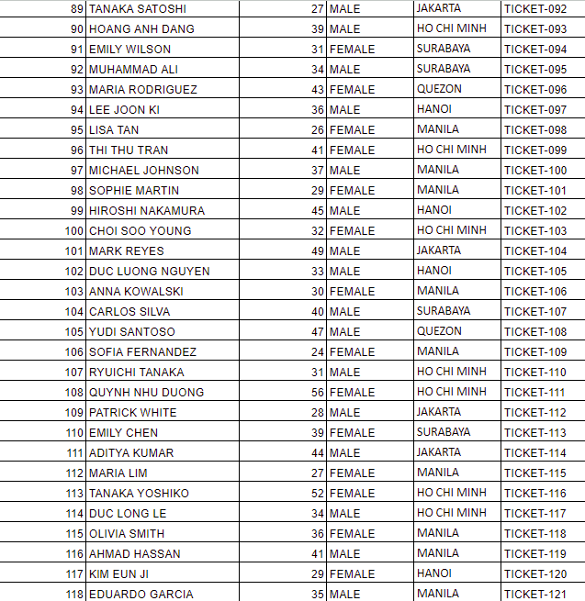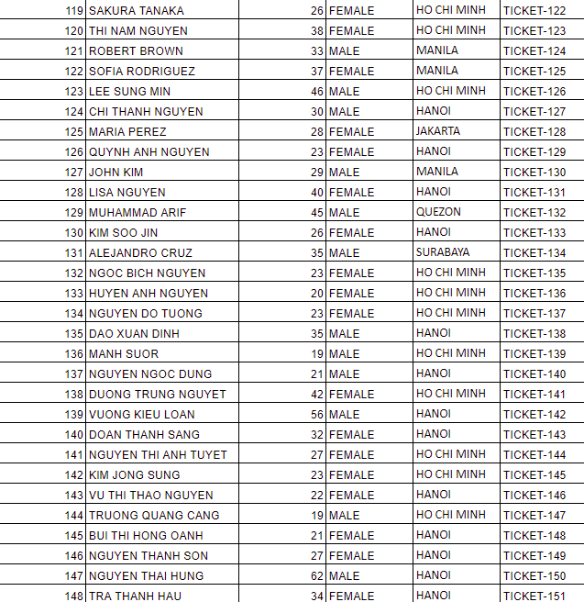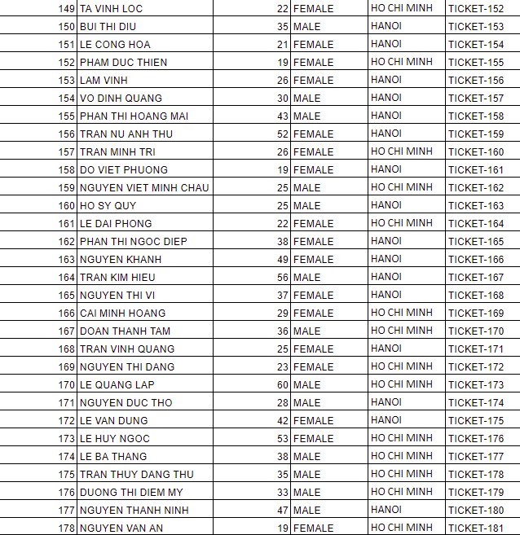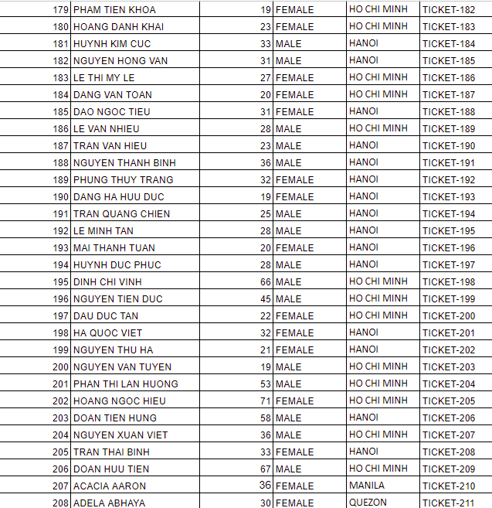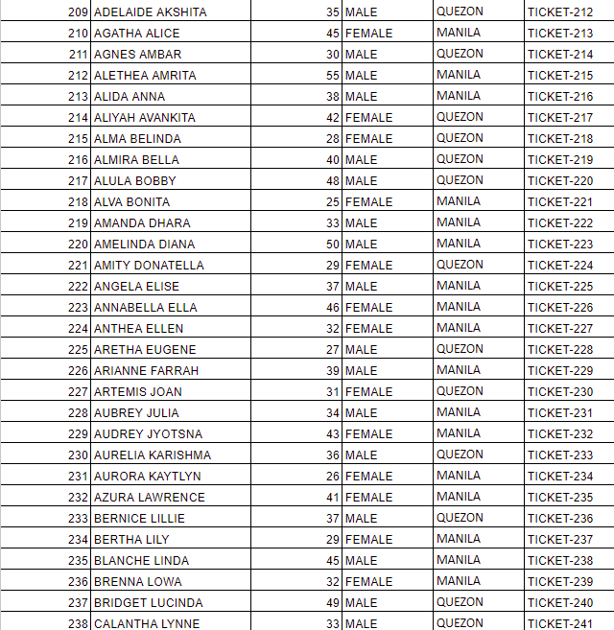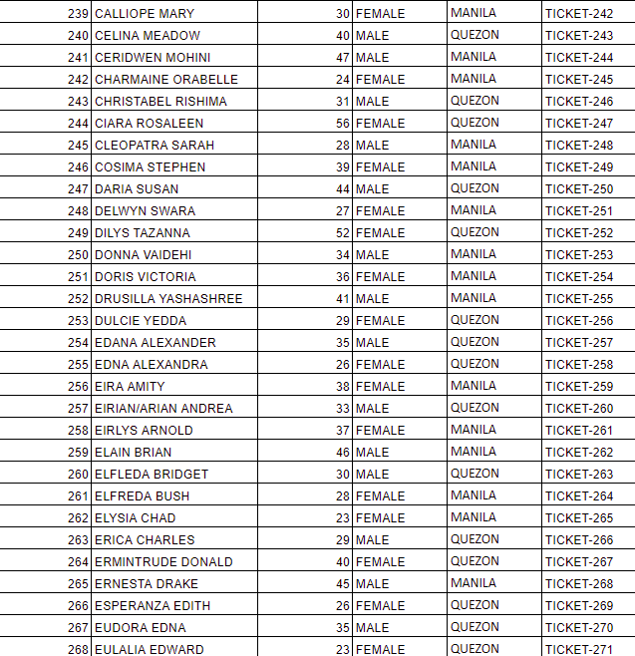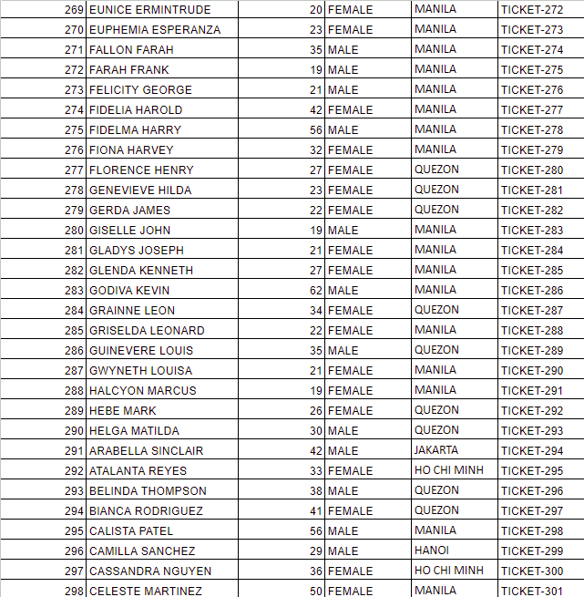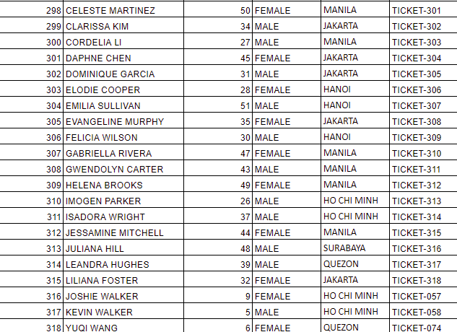

**8. TICKET**

This table provides information about the tickets and all the information which related to a ticket. Once customers purchase tickets, their payment dates and time will be transcribed into this data table. Not only that, all the information of the ticket, which are ticket numbers, the class type and the seat number of the ticket, and the name of the office which responsible for those exact tickets, will also be noted in the data table.

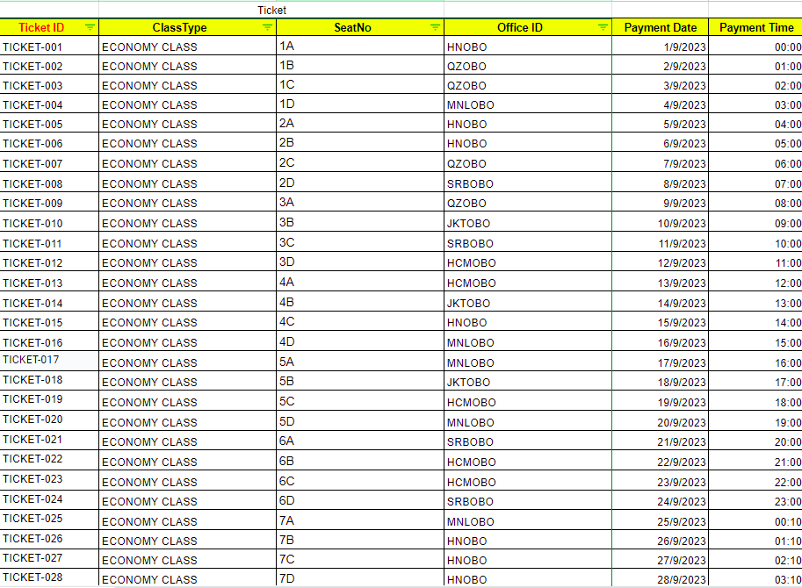

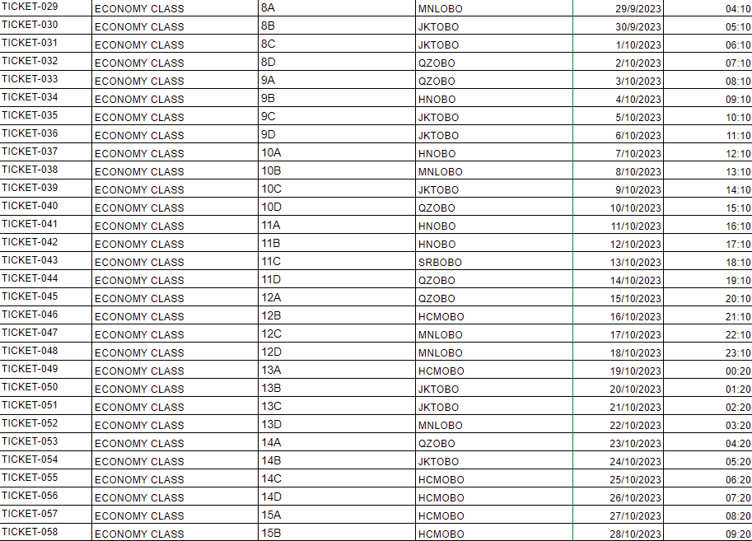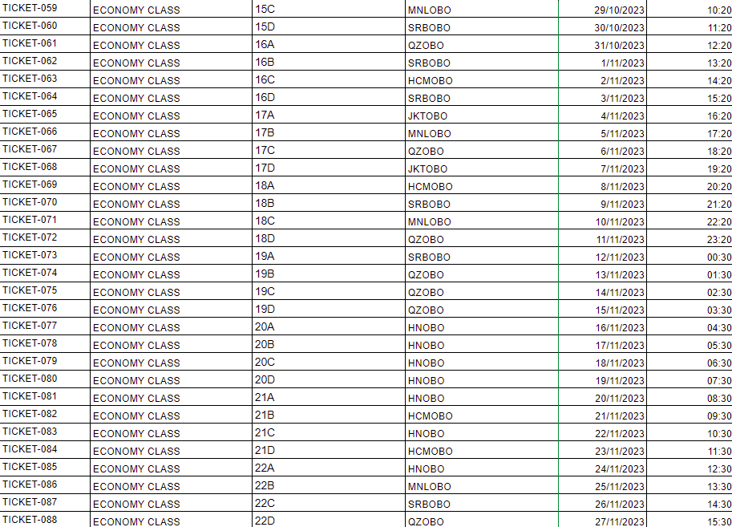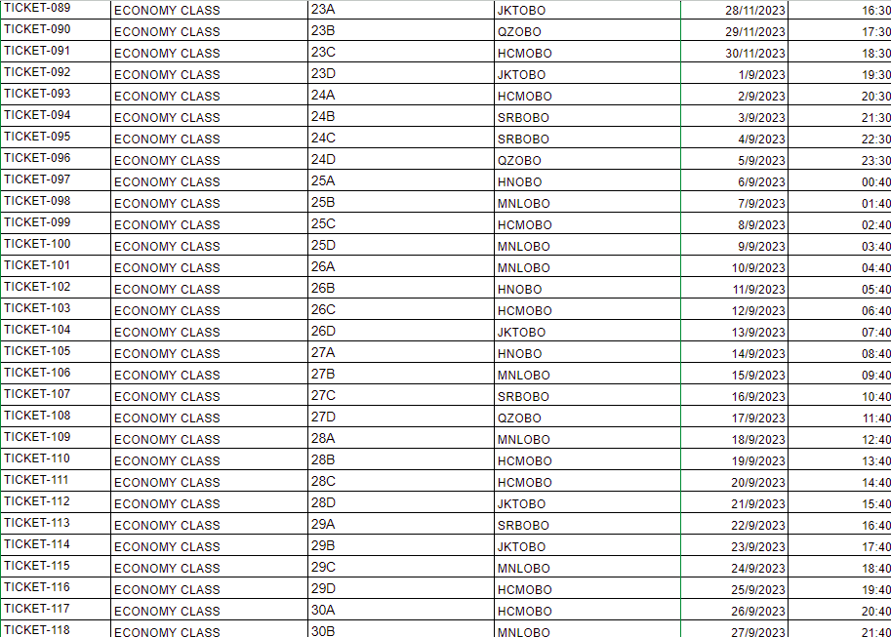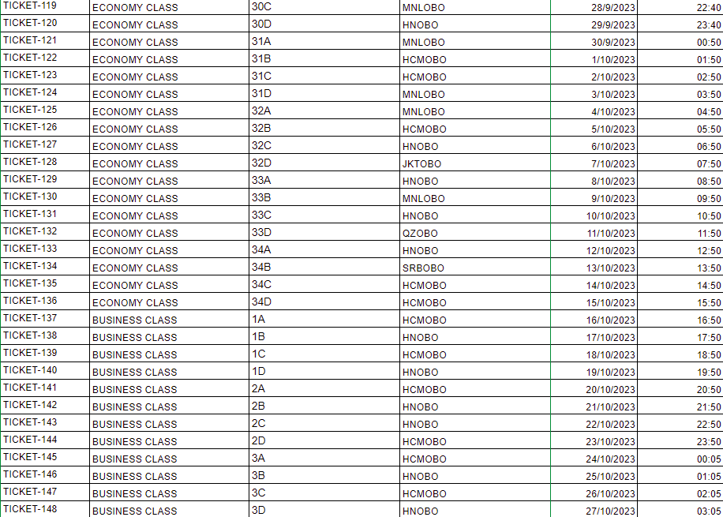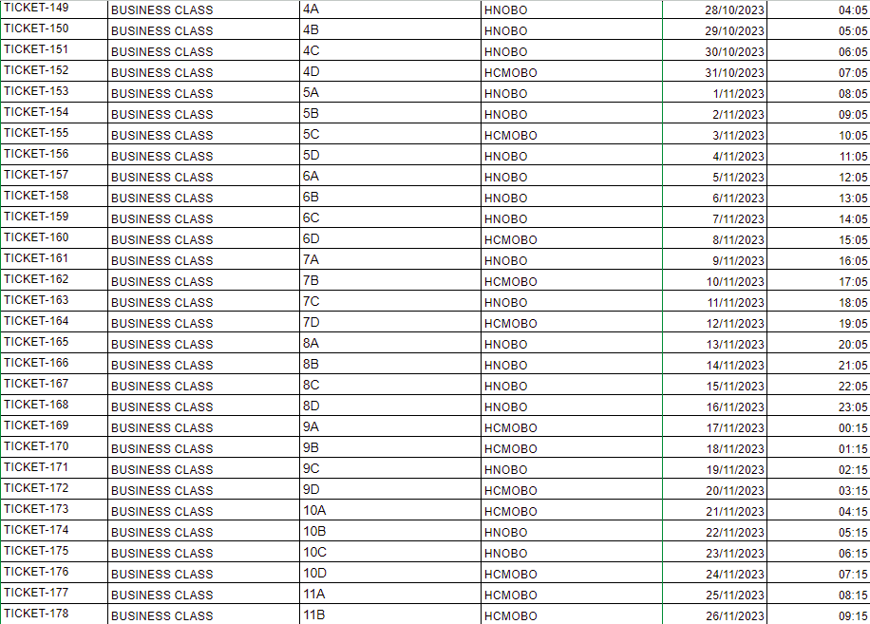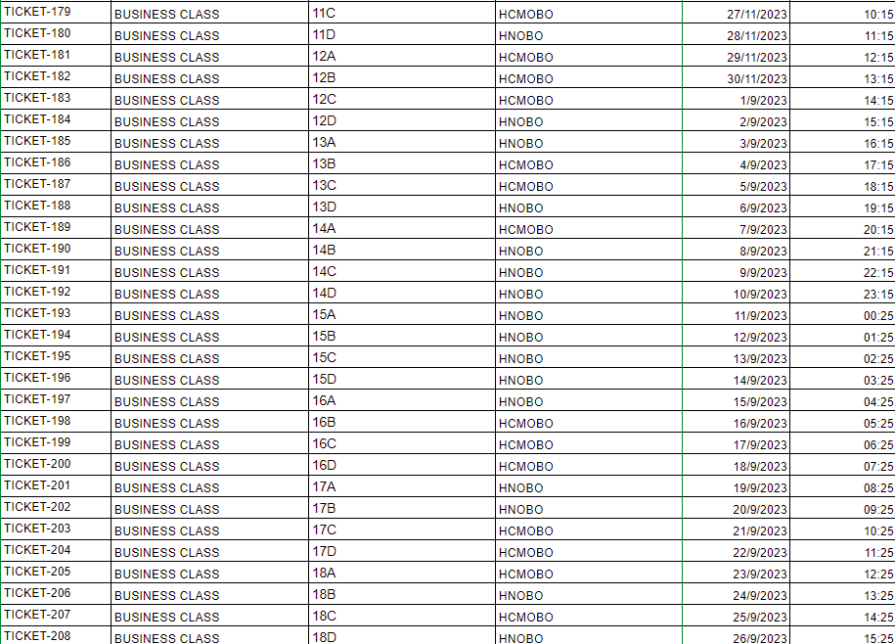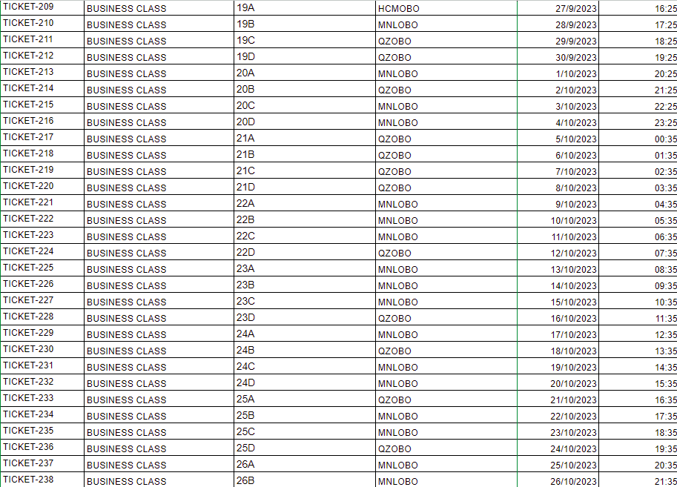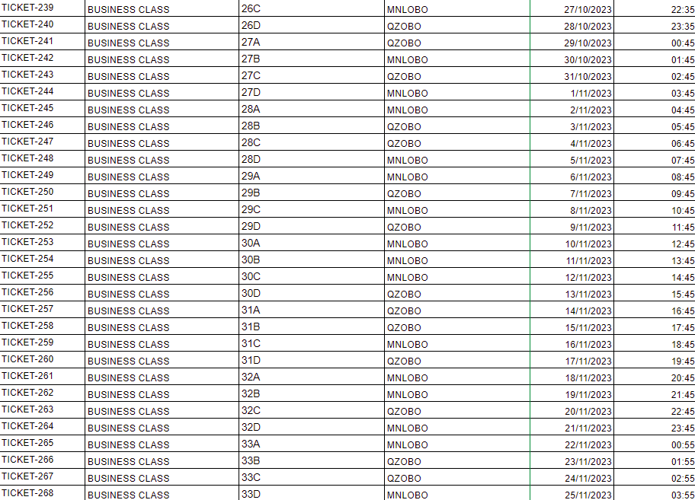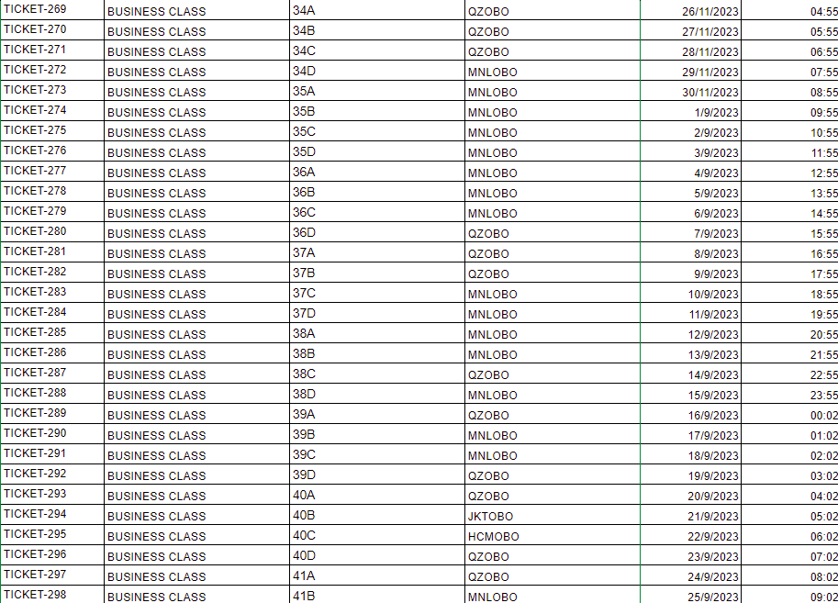

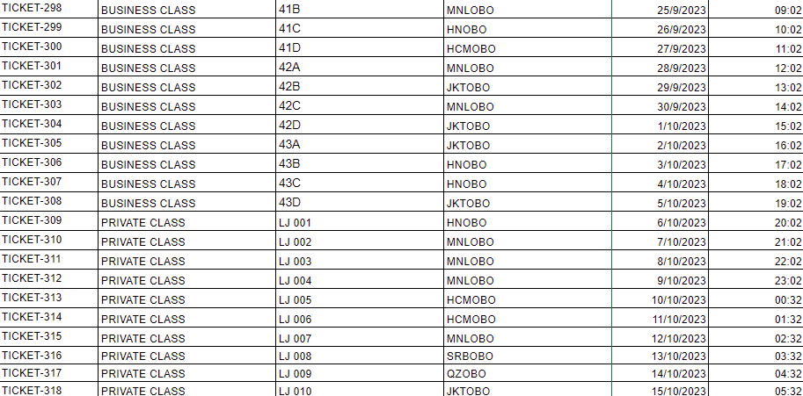

**9. CLASS TYPE**

This table illustrates the information about the fare classes which the airline is currently selling; which are Economy class, Business class and Private class. The identity code of the office which responsible for each flight, the flight number, the name and codes of the fare classes are the information that included in the table.

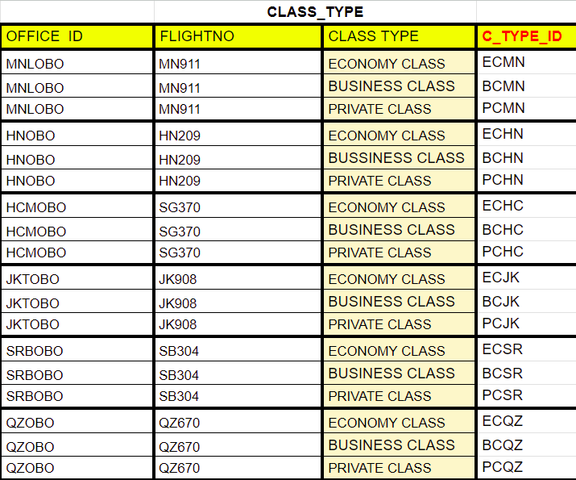

**10. FARE**

The table shows the differences among the fares of each flight classes. According to this table, we would know how much of money that the airline spend on operating each route, and logically calculated the final price. Or, we can say, the airline has considered the final price base on the operating cost and costs incurred, in order to balance their expenses and revenue.

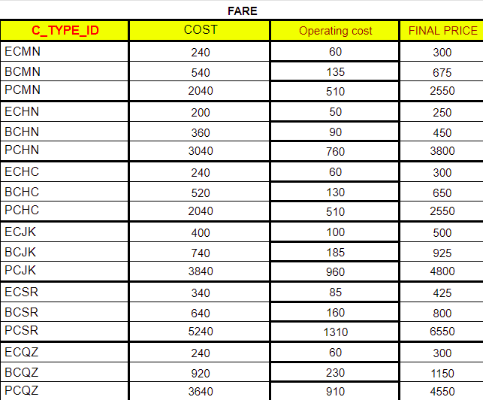

**II. ER DIAGRAM AND SCHEMA**

1. **ER DIAGRAM**

***The meaning of the ER Diagram:***

The airline has many airplanes; all of them have different models as well as capacity and quality. Each airplane is identified by its Recognized Number (RegNo), and has attributes such as type and the number of total seats. An airplane can make many flights.

Each flight is identified by its flight number, and has attributes route, departure date, and time, as well as arrival date and time. Each flight can be made by just one airplane, so it goes with a unique Recognized Number of the airplane.

Each flight is controlled by a cabin crew. A member of the cabin crew has a specific ID, and the cabin crew has attributes like the captain’s name and flight number. One cabin crew only controls and serves on one flight.

Airports, which are located in different cities in different countries, have different IDs. It has two attributes country and city. Each flight can land or depart from many airports, but each airport is allowed for each flight to land or depart once, which means each airport connects to specific flight numbers.

A booking office is identified by its ID, which also shows where it is located. Each booking office has its name, and also flight numbers. A booking office can make bookings for many flights, but each flight can only be operated by one booking office.

Class types are classified by booking offices. It is identified by IDs, and it has attributes such as class type, office IDs, and flight number. The booking offices classify the seat classes for each respective flight.

The fares for the flights are evaluated by the booking office. Each fee class will correspond to different IDs, which have different final prices. To infer the final price, we need to infer it from cost and operating cost.

Tickets are sold by booking offices. Each ticket is distinguished by its ticket number, and it has attributes seat number, class type, payment date and time. The tickets are issued by booking offices. A booking office can issue many tickets, but each ticket is only under one booking office.

Passengers who are adults can purchase tickets. Each passenger is identified by their ID (P_ID_A), and it has attributes name, age, gender, contact numbers, e-mail, and city. Each passenger has a unique ticket number. A passenger can purchase many tickets, but one ticket only belongs to one passenger.

Passengers who are children are responsible for them by their adults. Each child is identified by an ID, and it has attributes such as name, city, and ticket number. Each child is under their legal tutelary’s name, and each child only has one legal tutelary. Vice versa, an adult can be responsible for more than one child. Each child has his/her own ticket, which means one ticket belongs to an exact passenger.

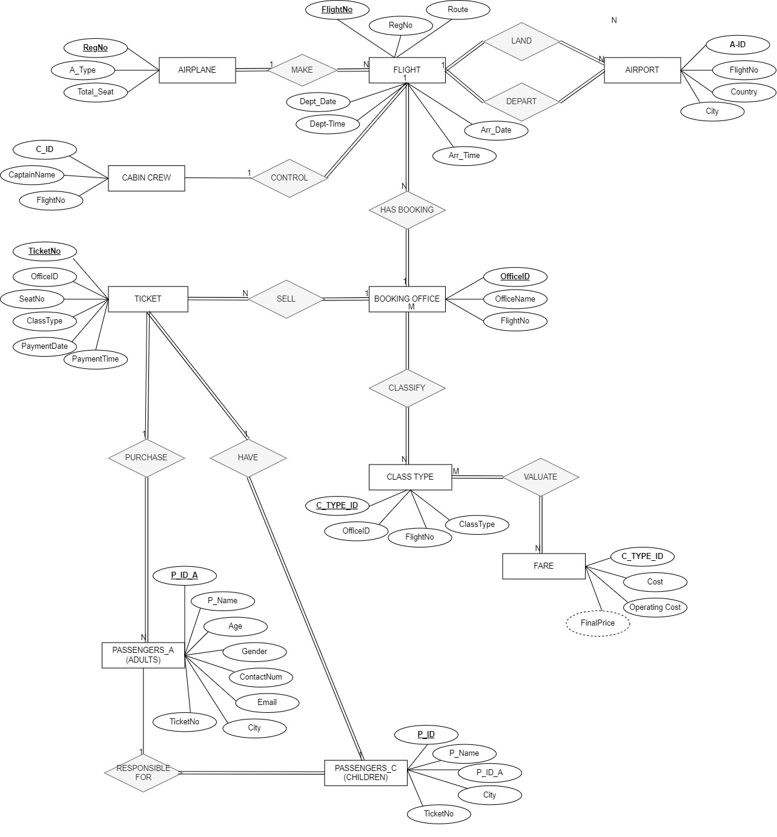

**2. SCHEMA**

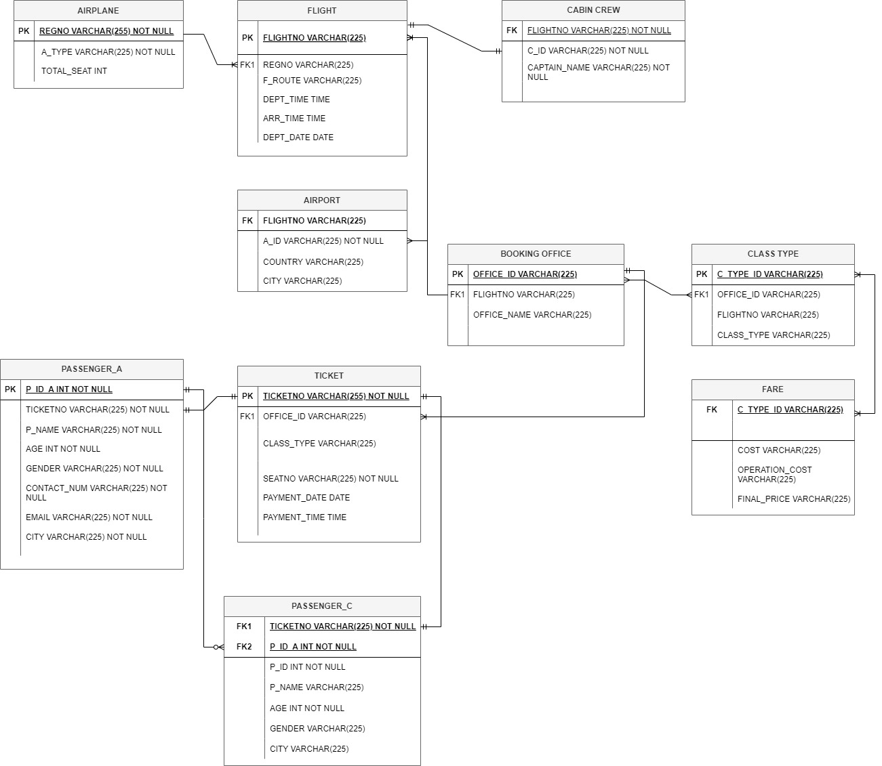

**III. LINKS AND SCREENSHOTS OF DASHBOARD**

**1. DASHBOARD FOR CUSTOMER**

a. **AGE CLASSIFICATION OF PASSENGERS**

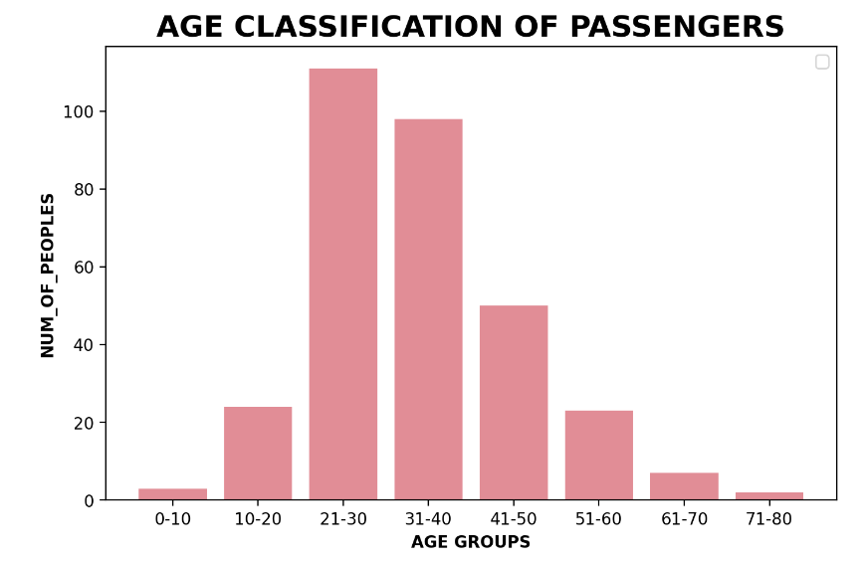

The data table above indicates that, out of all the passengers, those in their twenties and thirties had the most remarkable statistics regarding 111 individuals. Conversely, the lowest number of passengers are those aged between 0, and between 10 and 70 or 80 (the former have three, while the later have only two).

The rationale is that, while they are in their prime, travelers who are in their twenties and thirties frequently have a lot of personal objectives, including world exploration, cultural immersion, leisure travel, and networking. network of relationships. Customers at this age can also afford to pay for travel, including using airline cards, because they frequently work independently and have jobs. Moreover, concerning population distribution, passenger categories from 0 to 10.

**b. AVERAGE TICKET’S PRICE PER COUNTRY**

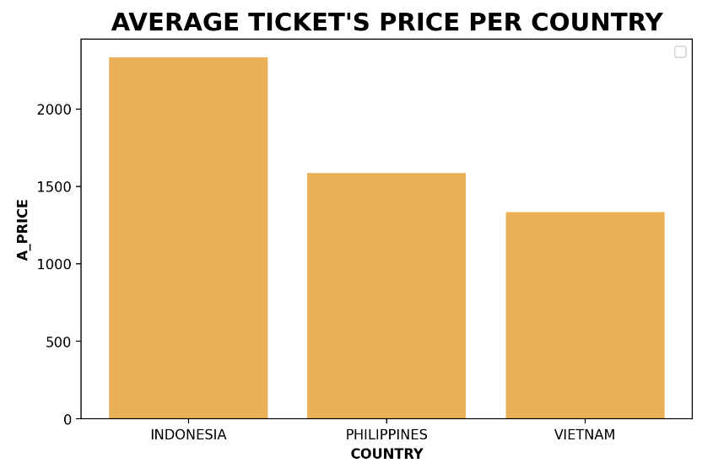

The bar graph below illustrates the differences among the ticket’s prices in each country. As we can see from the graph, the average ticket price, which is applied for Indonesia, reached more than $2000. This number is completely higher than Philippines, which has the average price as more than $1500, and nearly twice than the ticket’s price in Vietnam, the country where the average price is only $1200. Overall, Indonesia is the country which hit the highest point, then Philippines and Vietnam respectively.

For this price difference, the root cause probably comes from the development of economies between countries. People in countries with faster-growing economies, or countries with better geographical conditions, will be able to afford to travel by air. This chart is designed to allow customers to see the close balance between the price and the economy of their country while understanding that the airline has worked hard to make the price adjustments as reasonable as possible.

**c. PERCENTAGE OF FLIGHT CLASSES**

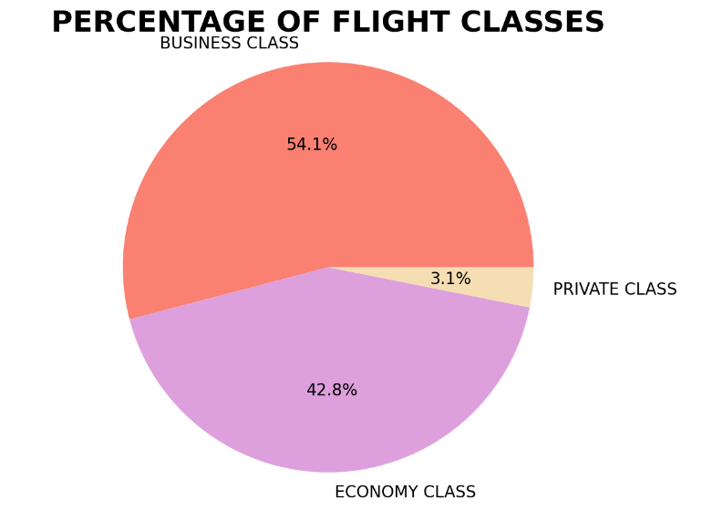

As we can see clearly in the pie chart, the business class makes up the largest percentage, as shown in the chart, with over 54%, while the private class only makes up slightly more than 3%.

This is because we concentrate on providing more business class flights because we are a premium airline. Customers are also prepared to pay more for a business class ticket than an economy class one because they are specifically interested in high-end services and premium flying experiences, such as having more options for meal menus and having private space on lengthy flights. This also could help customers to choose their ticket class based on this figure, which also indicates which ticket class is flown more frequently.

**d. NUMBER OF FLIGHT BOOKINGS PER WEEK IN A MONTH IN**

**EACH COUNTRY**

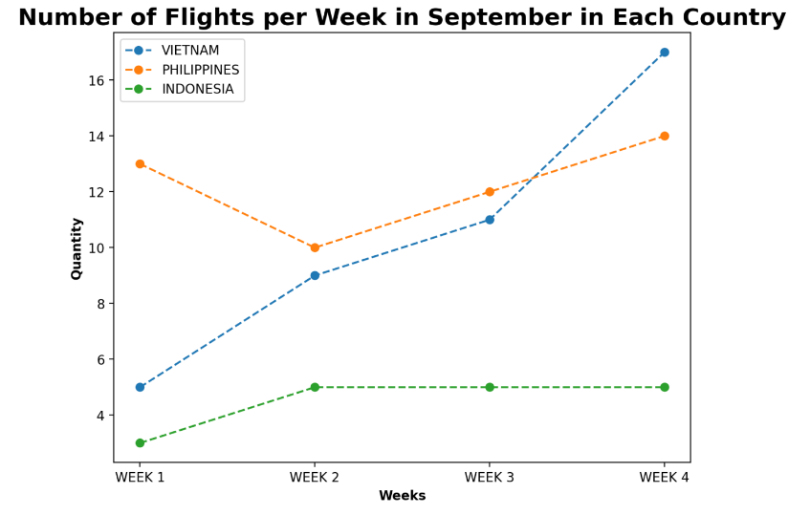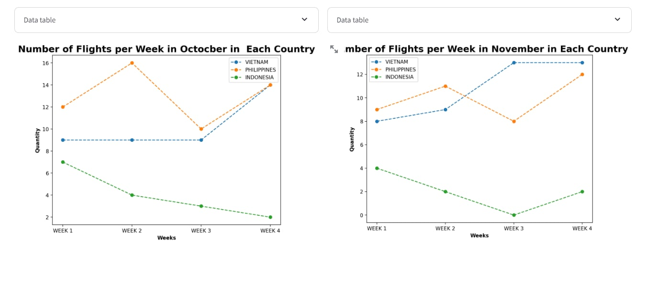

The line charts indicate the number of bookings that the airline has received in a period of time, as well as revealing the frequency of bookings per week for each month in different countries (which are Indonesia, Philippines and Vietnam).

**+ September:** According to the first graph, we can clearly see that both Philippines and Vietnam had a fluctuation among the first week and the next two weeks, despite the fact that the number of bookings were made in Philippines slightly drop, when Vietnam’s increased. Then Vietnam and Philippines both hit the highest point at the last week,

which were more than 16 bookings per week and 14 bookings per week respectively. With Indonesia, it remained stable all the month, and once reached a peak at 5 bookings a week at the second week of September.

+ **October:** This line graph gives information about the considerable change of the number of bookings in each country. The Philippines, although the bookings density was stable the previous month, recorded a significant change in the second and third weeks of October. The number of bookings reached a peak, at 16 a week, in the second week of the month, but suddenly dropped sharply the following week, to just under 10 bookings a week. Besides, Vietnam remained stable for the first three weeks of the month, and reached its highest number in the last week - more than 14 bookings a week. Most notably is Indonesia, the number of bookings dropped sharply over the four weeks of October from almost 8 bookings in the first week to 1 in the last week of the month.

+ **November:** As we can see form the chart, the number of bookings in Indonesia and Vietnam is still higher than the Philippines. Similar to the previous months, the number of November weekly bookings in Indonesia and Vietnam remained stable, with no significant increase. However, in the third week of the month, the number of bookings in Indonesia increased to more than 12 per week, while Vietnam, on the contrary, dropped from 12 to 8 bookings per week. In the last week of this month, both countries were recorded with equal frequency - 12 bookings a week. Meanwhile, the number of bookings in the Philippines tend to decline in the first three weeks of the month, from 4 bookings during the first week to none during the third. However, the number of bookings increased slightly in the last week of the month: to 2 bookings a week.

In conclusion, we can see that the data tables show us detailed information about the number of bookings in a given period of time. Thanks to this chart, customers can deduce which times will be less bookings and which time will be more, from which to calculate when they can book their own tickets, thus preparing the right financial as well as plans for themselves and their families.

**2. DASHBOARD FOR CEO**

**a. NUMBER OF BOOKED CLASS**

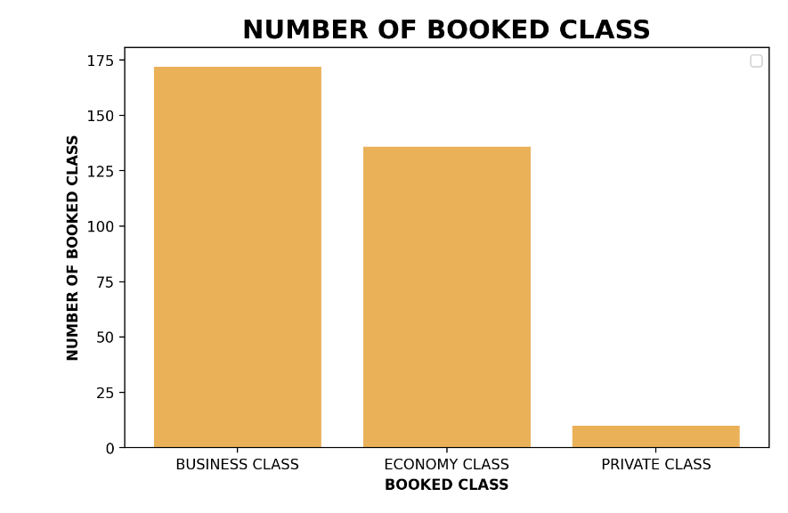

The flight class with the most bookings among the Economy, Business, and Private classes is displayed in the bar chart below. With almost 175 reservations, it is evident that the Business class has the most bookings. But with just ten reservations, the Private class has the fewest compared to the Business class.

This is due to the fact that business class travel provides a more opulent experience, completely with spacious chairs that can recline all the way. Furthermore, business class passengers sometimes receive fine wines, drinks, and premium beverages in addition to gourmet meals with multiple options. Business class's appeal is also influenced by the privacy and convenience it provides. There is a significant time savings because passengers in this class always get priority check-in, security, boarding, and baggage claim. In order to keep them from getting bored or hungry as they wait to board, business class passengers have access to a separate lounge that offers food and beverages as well as rest areas.

The reason why the Private class is the least popular is because it is more expensive than the Business class. The reason that leads to the high fee is the flexibility to alter the flight itinerary at the last minute to suit the needs of the passenger. Additionally, this course makes use of private airports and the newest planes, all of which have complete amenities including desks, beds, and roomy restrooms and showers. Lastly, the primary audience for this class includes affluent people, famous people, and influential figures who want an entirely quiet and undisturbed journey. The low amount of reservations for this class in comparison to the other two can be attributed to these factors.

- **Recommendations for Improvement**:

+ Provide better rest areas and food services for all flight classes, particularly Economy.

+ Adopt sensible policy and preferential for the airline's patrons and devoted patrons.

+ Step up marketing and advertising campaigns, and work with partners to improve brand awareness at travel locations.

**b. PROFITS BY COUNTRY**

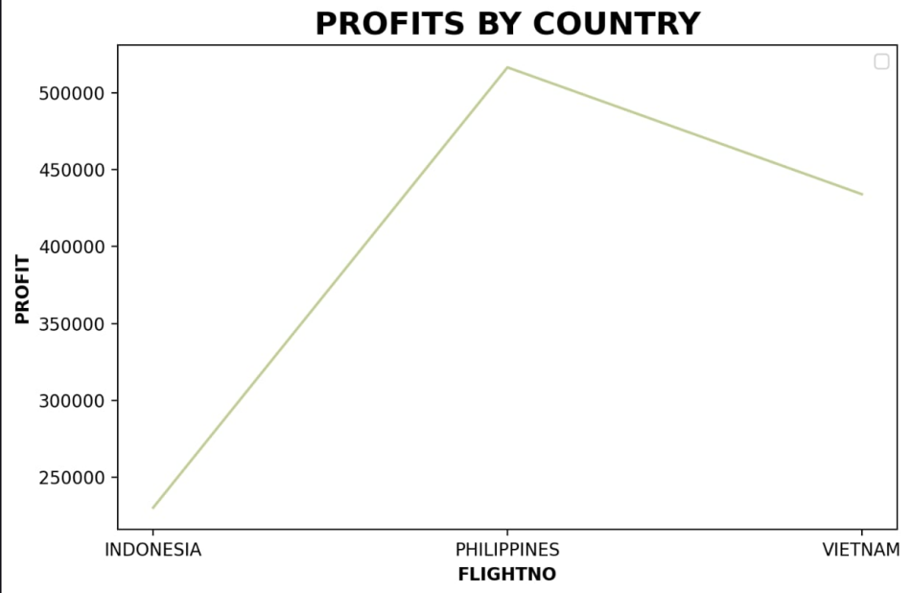

The income from selling airline tickets in two cities spread over three nations - Vietnam, the Philippines, and Indonesia is displayed in the chart below. It's evident that Indonesia made the least amount of money - just a little bit more than $200,000, while the Philippines made more than $500,000, made up the highest amount of money. This suggests that compared to the four cities in the other two countries, ticket sales are more successful and higher in the two cities in the Philippines.

The reason for this case is that the Philippines generates the most money from the selling of airline tickets. There is a strong demand for flights due to the nation's well-developed tourism industry and its several well-known tourist attractions, which draw visitors from both domestic and foreign travel. As an archipelago with over 7,000 islands, air travel is more prevalent and necessary compared to Vietnam and Indonesia. Furthermore, the Philippines' air freight business is flourishing thanks to robust import and export activity as well as a developing labor export market. Filipinos have a greater need for air travel due to travel, business travel, and visiting distant relatives. Our airline's successful marketing and advertising campaigns have also increased its popularity in the Philippines relative to the other two nations. Together, these elements lead to the highest revenue from airplane ticket sales in the Philippines.

The reason Indonesia has the least amount of revenue from the sale of airline tickets is because our airline's marketing and advertising campaigns have not been very successful. Due to its developed economy and the large number of airlines that have previously expanded and invested there, Indonesia presents a difficult market for a new airline like ours to compete in.

- **Recommendations for Improvement**:

+ Modernize amenities at major airport terminals, including lounges, check-in desks, and customer service.

+ Increase the size and variety of air networks in developing nations.

+ Create marketing plans that are specific to each nation and its unique economic environment.

+ Put into practice the right policies and plans to address regional needs.

**c. REVENUE BY TYPE OF TICKET**

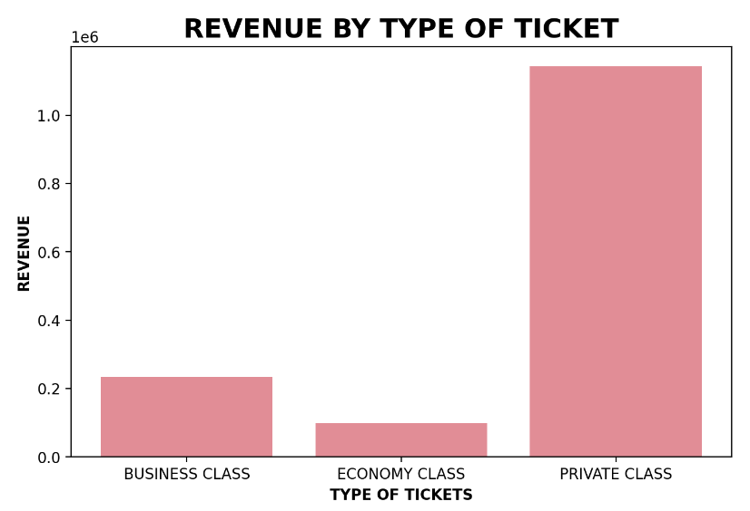

The revenue (unit: million dollars, as 1e6 represents for six number 0) from ticket sales for each class offered by our airline is displayed in the bar chart below. It is evident that of the three classes, the Private class has the most revenue even though it sells the fewest tickets. The Economy class, on the other hand, has the lowest revenue.

The reason that leads to this is because it is the most expensive of the three classes, the Private class earns the most money. It thus makes the most money even though the fewest tickets are sold there.

As for Economy class, the reason for its lower sales is that our airline is established as a premium airline. Therefore, even for Economy class, we always provide passengers with the finest and most luxurious amenities. This results in higher ticket prices for this class compared to other airlines, leading to increased competition in pricing between our classes and those of other airlines.

- **Recommendations for Improvement**:

+ Enhance promotion and marketing.

+ Analyze and adjust strategies to understand customer needs, thereby adjusting pricing and services accordingly.

+ Offer special promotional programs.

**d. NUMBER OF BOOKED FLIGHT**

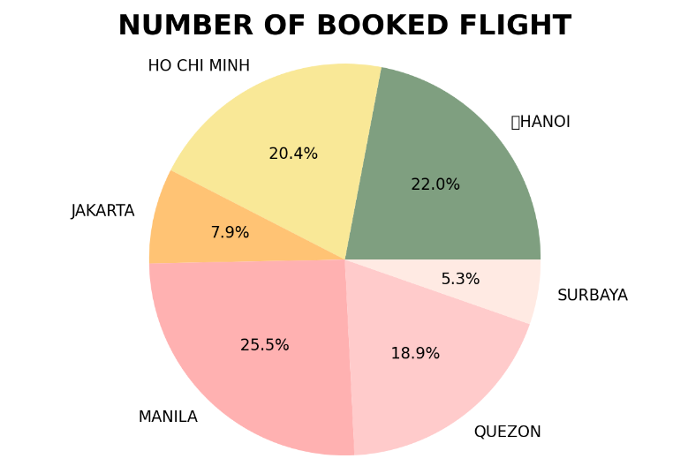

The flight route with the most bookings is depicted in the pie chart below. The figure indicates that, with 25.5% of bookings, the Manila route has the greatest booking rate. The two routes with the lowest booking rates are Surabaya and Jakarta, with 5.3% and 7.9%, respectively.

The reason why Manila has the highest number of bookings is because this place is the capital, economic, political, and commercial center of the Philippines. A lot of large international businesses and organizations are concentrated here, and this leads to a high demand for commute for business meetings, conferences, and other events. Furthermore, Manila is one of the most popular tourist destination where attracts many international visitors. Alongside, our tailored marketing policies and strategies for this destination also contribute to its high booking rate. All these factors collectively make Manila becomes the route which owns the highest number of flight bookings among the six cities across three countries.

On the other hand, the two Indonesian cities have the lowest booking rates. This is because, out of the three nations, Indonesia has the most developed economy, which has led to the existence of a large number of domestic and international airlines. This fierce rivalry presents a big obstacle for a brand-new airline like ours. The intense competition in Indonesia's ticket sales market poses a significant challenge and source of worry for our airline. These therefore explain why, out of the six cities, the two cities in Indonesia have the lowest booking rates.

- **Recommendations for Improvement**:

+ Provide special offers and reduced costs for flights between the two Indonesian cities.

+ Put into action a customized marketing and branding plan to raise airline brand recognition and expand flying schedule in Indonesia.

+ By raising the caliber of flights and onboard amenities, raise the standard of service and the overall traveler experience.

**3. DASHBOARD FOR LOCAL MANAGERS**

**a. NUMBER OF BOOKED FLIGHTS**

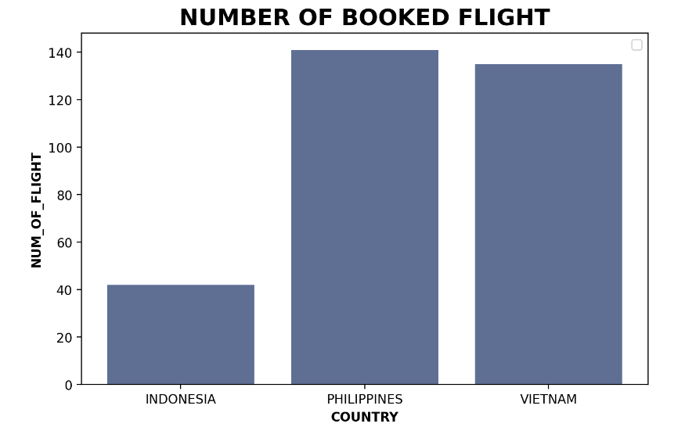

The bar graph illustrates the difference of the number of booked flights among three countries Indonesia, Philippines and Vietnam. According to the graph, the number of flights were booked from Indonesia is the lowest one, with just 40 bookings after three months. Meanwhile, for the Philippines and Vietnam, the number of bookings is still at a reasonable level. SEA Airbus has received a lot of support and popularity in the Philippines, so it's the country with the highest number of pre-booked turns, with 140 bookings in over three months. Next is Vietnam, a new market full of prospects that SEA Airbus has just begun to explore. The number of flights booked from Vietnam in three months has reached nearly 140, just a little less than the Philippines.

Thus, from the above bar graph, the local manager will be able to see the potential as well as the characteristics of the three Southeast Asian markets, then giving the right direction of development for the region he/she is in charge of.

**b. REVENUE AND OPERATING COST RATE**

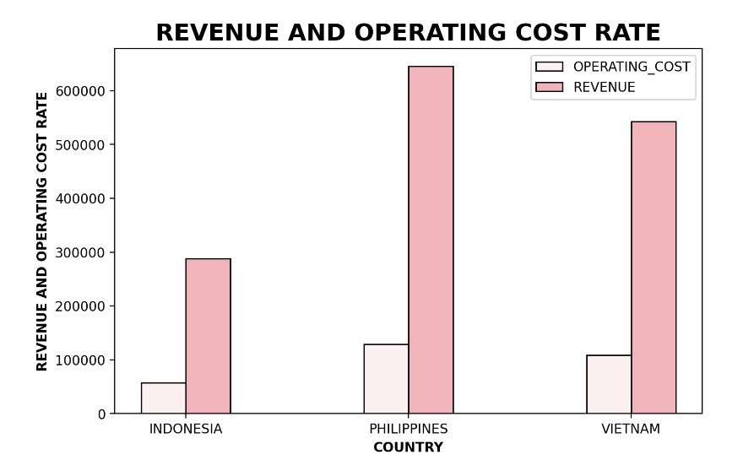

The income and operating expenses of an airline in three different nations are shown in the data table below. Between the three countries, it is clear that Indonesia has the lowest revenue and operational costs, while the Philippines has the highest.

As for, even though this country has the lowest revenue and operating costs, the airline's operating costs are less than its revenue. This is encouraging news for our airline. However, Indonesia has the fewest flights out of the three, which contributes to the low revenue and intense competition among airlines in the aviation sector.

However, out of the three nations, the Philippines has the highest operational costs and revenue. Nonetheless, it is evident that the nation's operational expenses are significantly lower than its revenue. The great demand for air travel among the local populace is responsible for the Philippines' significant earnings from ticket sales. In addition to drawing a sizable influx of visitors from outside, the Philippines is also in great demand for import and export operations. Alongside, the significant revenue from ticket sales in this nation has been facilitated by our customized marketing techniques. The high revenue suggests that a large number of customers who fly with us, which raises the costs associated with running and maintaining the airline. Because of this, out of the three nations, the Philippines has the highest revenue and operational costs.

For Vietnam, the operating costs and revenue of the airline fall in between those of the two countries. This indicates that the airline is operating quite steadily in the Vietnamese market.

**c. REVENUE GROWTH RATE**

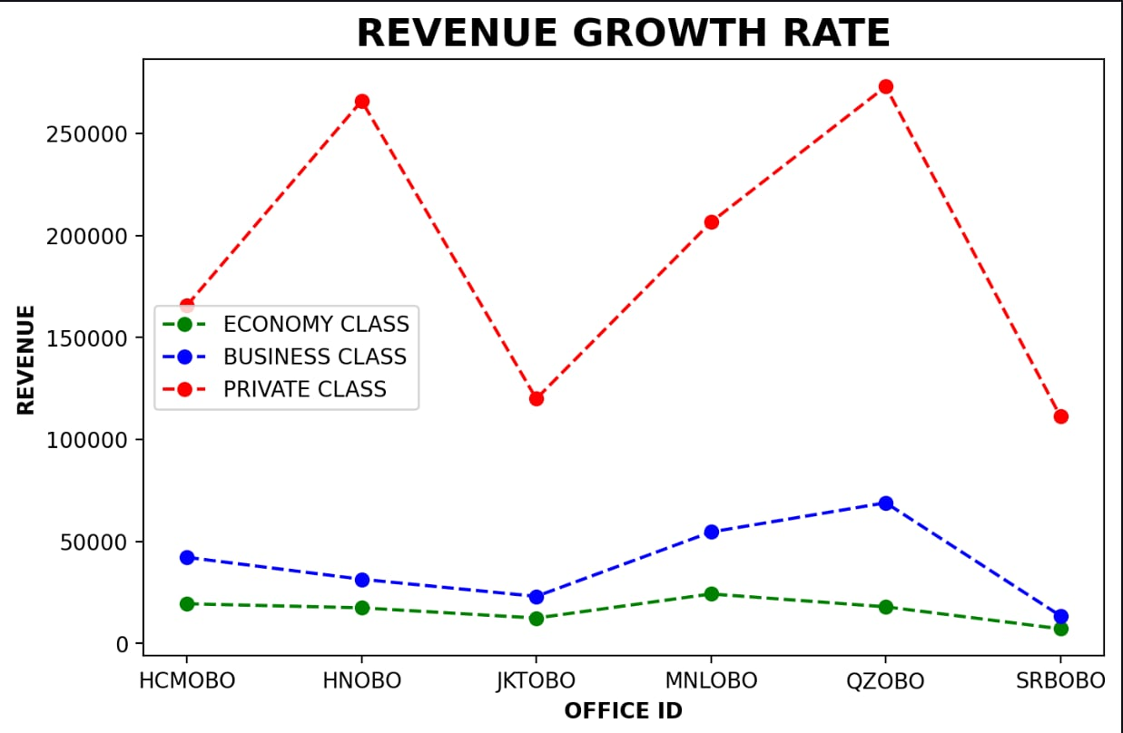

The revenue growth for each ticket sales location in six cities across three distinct nations is shown in the line chart below. The figure indicates that the two sites that generate the most money from the sale of private class tickets are HNOBO and QZOBO. Next, in terms of income from selling business class tickets, MNLOBO and QZOBO are the top spots, whereas MNLOBO is the top site for revenue from selling economy class tickets.

MNLOBO is the location with the most income for economy class tickets, while SRBOBO has the lowest revenue. This is because there is a greater demand for travel from both locals and tourists in Hanoi, the capital and cultural hub of Vietnam, due to its larger population than Surabaya. Furthermore, Hanoi's economy class tickets are more well-liked because of their reduced costs, which make them appropriate for short-haul and regular travelers.

When it comes to business class tickets, QZOBOB is the most popular spot and generates the most income. In contrast, SRBOBO generates the least amount of revenue; at this location, the revenue from business class ticket sales is equal to that from economy class sales. In addition to marketing tactics and amenities designed with the local populace in mind, Quezon City's strong demand for upscale amenities is the primary driver of the city's high revenue from business class tickets.

HNOBO and QZOBO are the places where have the highest revenue of purchasing private class tickets, whilst JKOBO generates the least amount of income. In Jakarta, however, the revenue from private class tickets is higher than that of the other ticket classes.

Furthermore, we can see that there is little difference in earnings between business and economy class tickets between cities. The money received from luxury class tickets varies significantly between cities, though.

**d. PROFIT FOR EACH AREA**

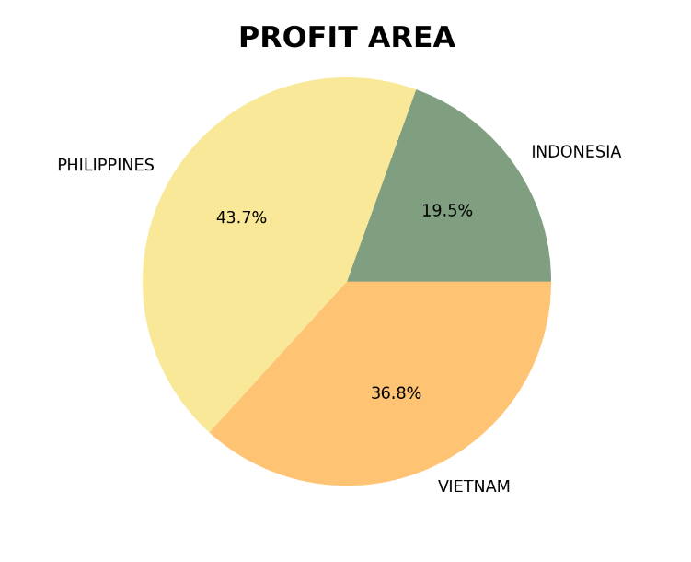

The pie chart below illustrates the profit of each city across three countries. It is evident from the chart that Indonesia has the lowest profit and the Philippines has the highest profit.

Because the Philippines sold the most tickets overall across all three classes of all three countries, it was the country with the largest profit. The preceding charts make this very evident.

On the other hand, Indonesia's low total number of tickets sold accounts for the country's lowest profit. To increase ticket sales in this area, suitable business and marketing strategies must be put into place.

**IV. SOME NOTICEABLE FUNCTIONS OF THE CODE**

In order to make sure that our code is clear, we decided to create a table which contains all the noticeable functions of the code.

|  |  |
| --- | --- |
| st.set_page_config | Configures the default settings of the page |
| st.cache_resource | Decorator to cache functions that return global resources (e.g. database connections, ML models) |
| st.cache_resource.clear | Clear all cache_resource caches |
| init_connection | The connection details such as server, database, username, and password are retrieved from Streamlit secrets |
| st.write | Write arguments to the app |
| st.sidebar | Add widgets to sidebar |
| st.cache_data | Decorator to cache functions that return data (e.g. dataframe transforms, database queries, ML inference). |
| run_query | Defined to execute SQL queries and return the results as Pandas DataFrames |
| st.columns | Insert containers laid out as side-by-side columns. |
| plt.figure | Create a new figure, or activate an existing figure |
| df.columns | The column labels of the DataFrame |
| plt.bar | Make a bar plot. |
| plt.xlabel | Set the label for the x-axis |
| plt.ylabel | Set the label for the y-axis |
| plt.title | Set a title for the axes |
| plt.legend | Place a legend on the Axes |
| st.pyplot | Display a matplotlib.pyplot figure |
| plt.plot | Plot y versus x as lines and/or markers |
| plt.pie | Plot a pie chart |
| plt.axis | Convenience method to get or set some axis properties |
| plt.xticks | Get or set the current tick locations and labels of the x-axis |
| st.expander | Insert a multi-element container that can be expanded/collapsed |

***This is the end of our report for subject “Database”.***

***Thank you for spending time reading and marking our group project!***

***----------------------------------------------------END-----------------------------------------------***